VMERS DC Set Up

NEMRC’s custom program for reporting payroll deductions and fringe benefits transactions destined for the State of Vermont Municipal Employees Retirement System Defined Contribution Plan is named PRCUS92A.

PRCUS92A creates both a file and a printed report. The report contains the same information as the file. The file is simply a text file formatted in a way mandated by the State of Vermont, and can be sent to them in order to satisfy their reporting requirements.

There is no limit to the number of times you can run PRCUS92A. If you decide that you’ve made a mistake you can upload again anytime before the due date. The new file will overwrite the old one. Refer to the procedure and information sheets distributed by the State Treasurer’s Office-Technology Division for remittance and reporting information.

Setup of a VMERS-DC deduction:

In order to correctly process deductions for the VMERS-DC plan, it is required that you have a standard deduction established within the Payroll module.

The standard deduction must have the deduction type code as G(ross), and the ‘Subject to what Withholding” and “Accumulate for what Wages” fields set up as IM, meaning exempt from State and Federal taxes, but taxable for FICA and MEDI taxes.

The Method id R(ate) and the percentage is as indicated by the State of Vermont.

The field indicated by “Direct Deposit” should be answered N(o).

If your Payroll Module is linked to General Ledger, then the liability account for this deduction can be the same as for similar deductions, or it can be an account dedicated to the VMERS-DC contributions.

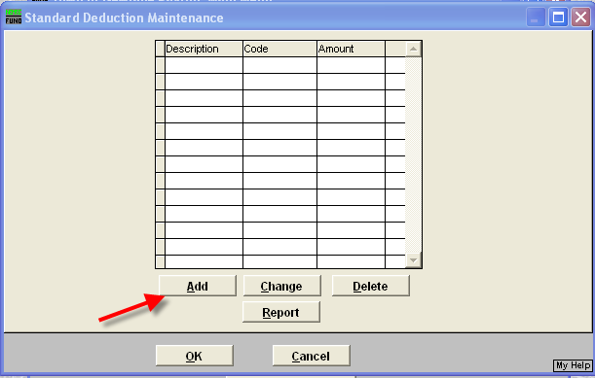

Click on F. Standard Deduction Table

Click on Add
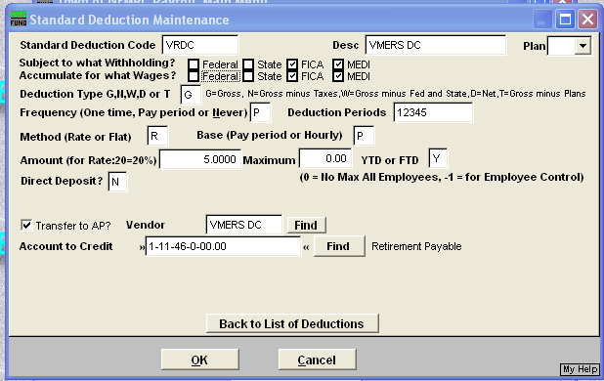

Fill in the information and click on OK to save it. If you do not transfer the information to Accounts Payable, unclick the transfer to AP box. If you do transfer, click on the box and input the vendor.

In employee maintence, pull up each employee who has the deduction, chose a deduction number, then click on the drop down menu and chose the VRDC standard deduction code.

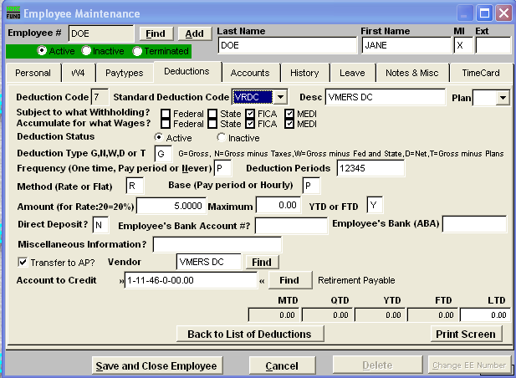

You will also need to set up a fringe for the employer’s share of the retirement:

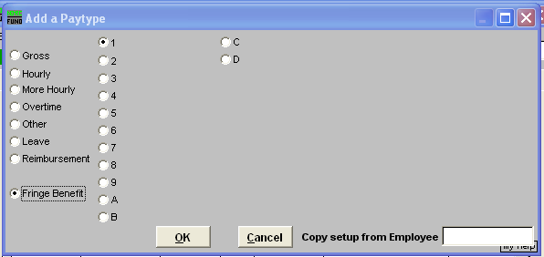

Add a paytype, chose Fringe Benefit and chose a number or letter. Make sure you are consistent with all employees.

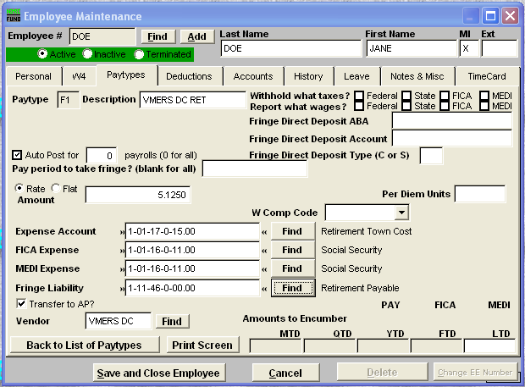

The fringe benefit is tax exempt from all taxes, so make sure all boxes are unchecked. Make sure it is set up as Auto Post, so the fringe is calculated each pay period.
Input the rate as indicated by the State of Vermont.

After you process your payroll, you will use prcus92a to create the report and file. You can save the file to a floppy disc or to your hard drive so you can upload it to the State of Vermont.

Enter the VMERS DC website and follow the instructions to upload the file.

